**Magical Piano**

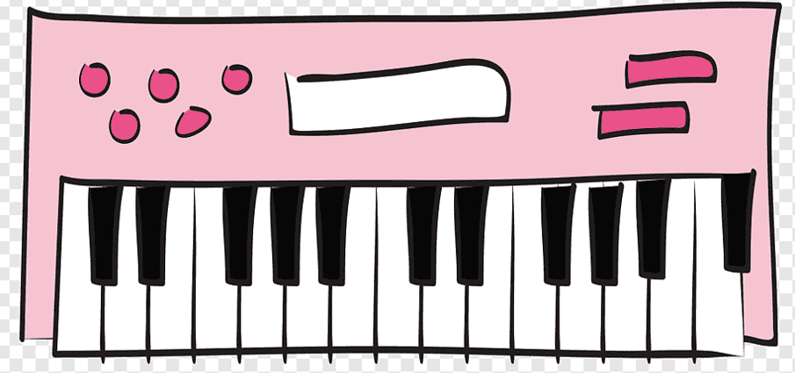

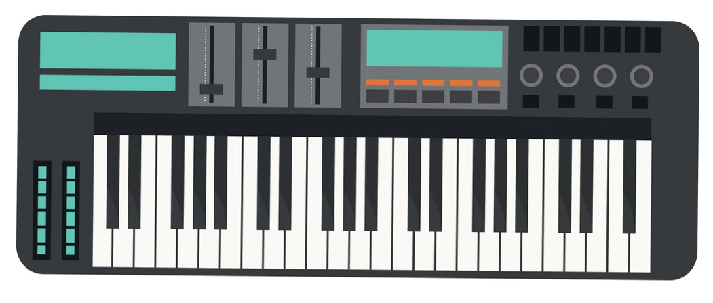

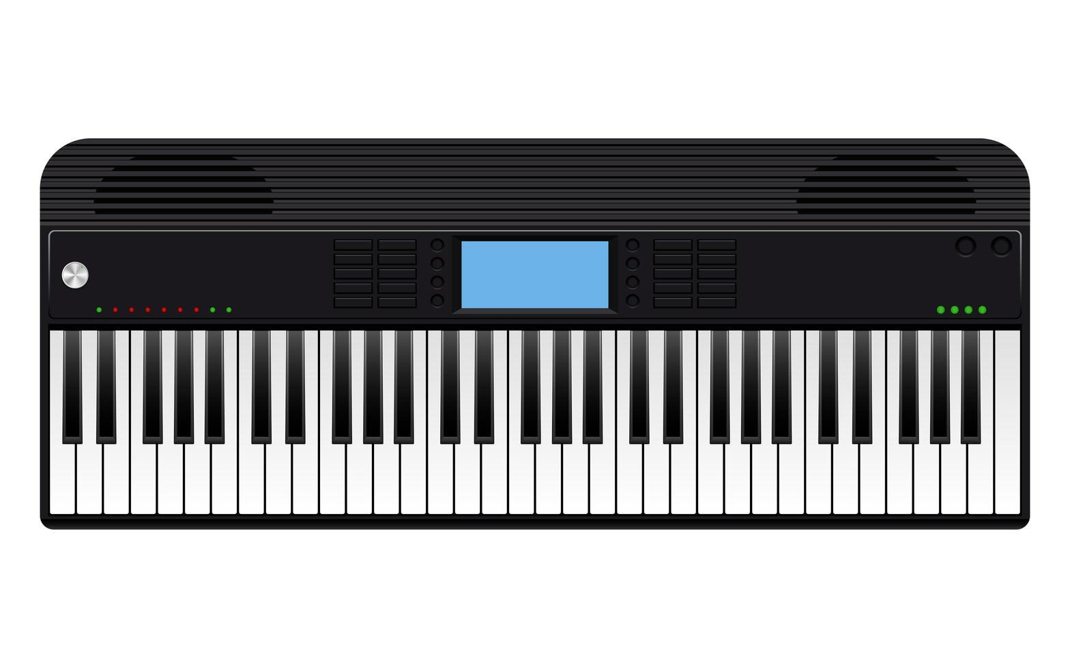

The Player has to play a role of a boy or a girl, who plays piano for people.

To play:

Players have to select their favorite nursery rhyme and play it on the piano. To play the piano, the player has to type the alphabet in the correct order. Few rhymes are correct and to unlock more rhyme player has to complete the given task.

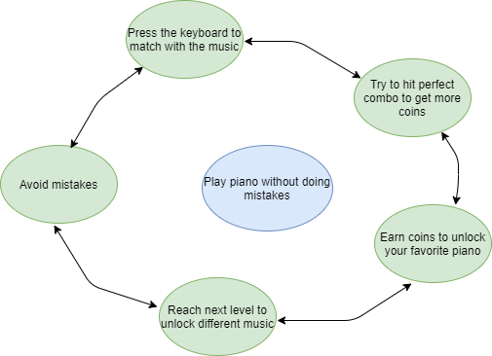

Genre: RPG, Music, Educational game, Text game, Keyboard game.

Secondary objective: Press the right key until the music is over.

First objective: Complete the music with a perfect score.

Level 1

Alphabet rhyme

- Player has to press the letters on their keyboard (a, b, c, d, and so on) to match it with music.

Link for music: <https://youtu.be/MKxxEHeSt44>

Level 2

Twinkle-Twinkle Little star

The player has to press type the word of the lyrics and the music (The lyrics will appear and glow from slowing with the word typed by the player). Players can set the music speed as they want.

Link for music: <https://youtu.be/8cUpo99vx48>

Level 3

- Itsy Bitsy Spider

The player has to press type the word of the lyrics and the music (The lyrics will appear and glow from slowing with the word typed by the player). Players can set the music speed as they want.

Level 4

- Baa, Baa Black sheep

The player has to press type the word of the lyrics and the music (The lyrics will appear and glow from slowing with the word typed by the player). Players can set the music speed as they want.

- Link for music: <https://youtu.be/A3tuCbT9Tqo>

Level 5

- Five little monkeys jumping in the bed

The player has to press type the word of the lyrics and the music (The lyrics will appear and glow from slowing with the word typed by the player). Players can set the music speed as they want.

- Link for music: <https://youtu.be/X63GtR1njyM>

.